Project Documentation: Chat Application

Syed Muhammad Ali Akbar Shah – 2024615
Abdul Raffay Gill – 2024019
Youraj Ali Karim – 2024666
Islam Uddin – 2024247
Ghazali Khan – 2024380

Table Of Contents

Introduction and Purpose………………….…………………………………2

Working Mechanism of Server Backend …………………………………3

Working Mechanism of Client Backend ………………………………..13

Working Mechanism of Database Backend …………………………..19

Working Mechanism of Client GUI Backend ………………………….22

Working Mechanism of Server GUI Backend ………………………….25

Introduction

This project has been created to act as a small-scale chatting application complete with features sufficient enough to allow users to navigate through the application with the assistance of a basic level Graphic User Interface, store login and password credentials and connect with multiple other users simultaneously.
The purpose of this project was to create chat application that was self-sustaining without the need for constant monitoring and servers, all the while allowing users to interact with each other in real time.
The project had been divided into three modules, namely socket programming implementation, Database implementation and GUI implementation. These modules were divided between two files the Server file and the Client file respectively.

Working Mechanism of Server.py Backend

Main features Implemented:
- Multi-threading for handling many clients
- Separate authentication server on port 6001
- Group chat server on port 5000
- TCP + IPv4 communication
- Client-server model (centralized message flow)
- User signup, login, logout
- Online user tracking with database
- SQLite database for storing users and status
- Auto-create admin account on first run
- Message broadcasting to all connected clients
- Safe removal of disconnected clients
- Thread-safe DB access with lock
- Thread-safe client list access with lock

Implementation of SQL For Database:
1. Overview
This Python code serves as the backend data layer for a chat application. It uses a relational database (SQLite) to manage user identities and session states. The primary purpose of this code is to ensure that user data (usernames, passwords, and online status) is stored persistently, meaning it remains saved even after the program is closed.
2. Libraries
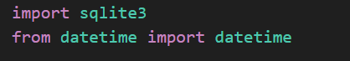
- import sqlite3: This is the standard Python library used to interact with SQLite databases. It is used because it requires no server configuration; the database is simply a file on the disk.
- import datetime: This module is used to capture the exact system time. It is essential for generating timestamps to track when users log in.
3. Function Breakdown

A. connect_db()
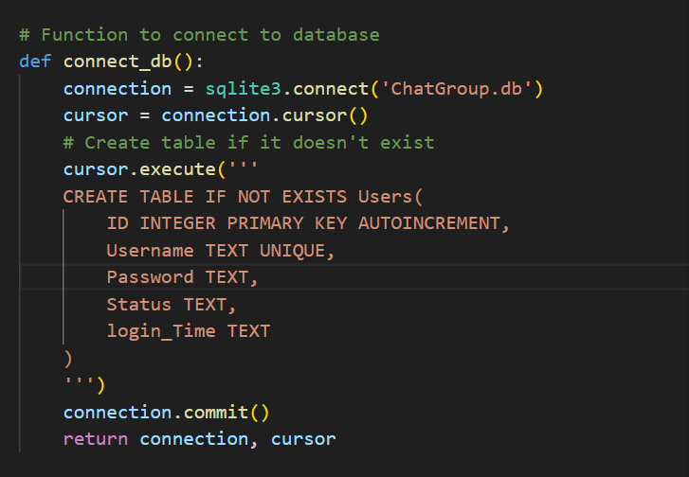

What it does:
  - Establishes a connection to the file ChatGroup.db.
  - Creates a cursor object to execute SQL commands.
  - Runs a “CREATE TABLE IF NOT EXISTS” query. This query creates a table if a table does not exist and this query is ignored if a table already exists.
Why it is used:
  - Connection: You cannot read/write data without opening a stream to the file.
  - Lazy Initialization: The IF NOT EXISTS clause is crucial. It ensures the program doesn't crash or overwrite data if the database already exists. It automatically sets up the infrastructure on the very first run.

B. add_user(username, password)
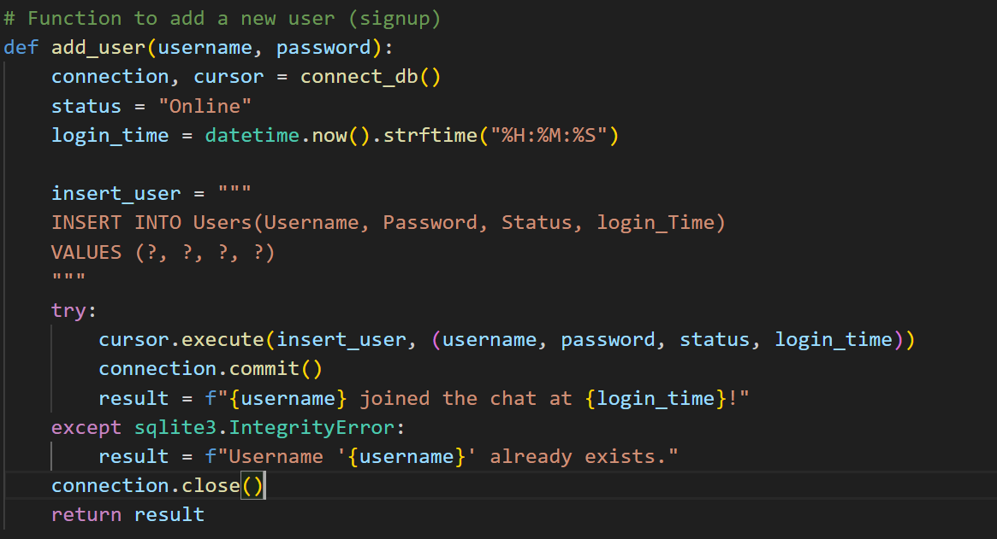
What it does:
  - Accepts credentials as input.
  - Sets the initial status to "Online" and captures the current time.
  - Executes an INSERT SQL command to add a new row to the Users table.
Why it is used:
  - Registration: This is the entry point for new users.
  - Error Handling: It uses a try...except block for sqlite3.IntegrityError. This is used specifically to handle the UNIQUE constraint on the Username column—preventing two users from having the same name without crashing the app.

C. login_user(username)
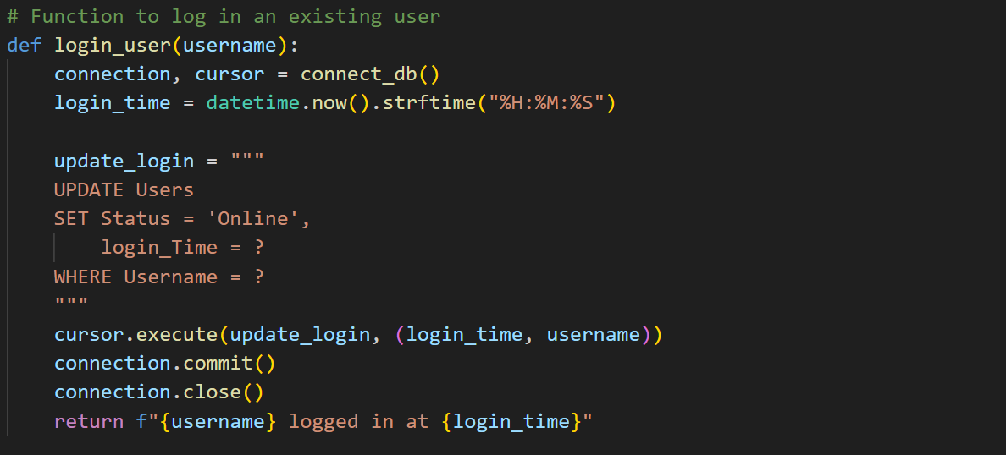
What it does:
  - Updates the user's state in the database without adding a new row.
  - Executes an UPDATE SQL command: SET Status = 'Online'.
  - Refreshes the login_Time to the current moment.
Why it is used:
  - State Management: When a returning user comes back, we don't need a new record; we just need to modify the existing one to reflect that they are active again.

D. logout_user(username)
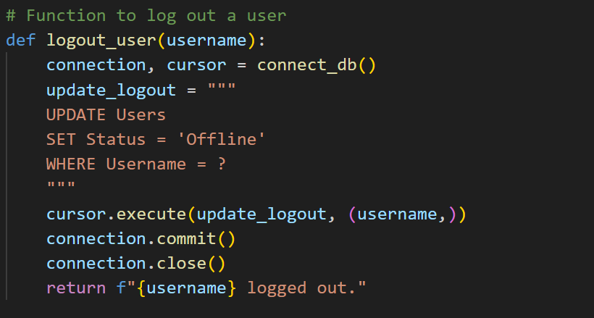

What it does:
  - Executes an UPDATE SQL command: SET Status = 'Offline'.
Why it is used:
  - Cleanup: This ensures that when a user leaves, they don't appear in the "Online Users" list for others. It maintains the accuracy of the chat room roster.

E. get_online_users()
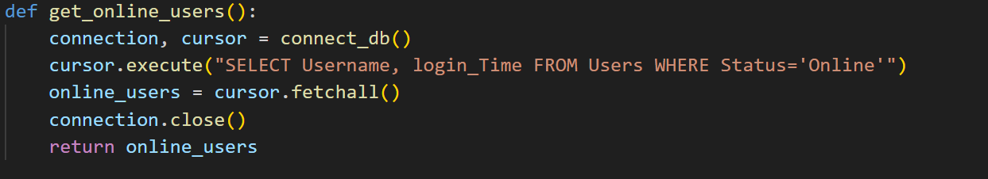
What it does:
  - Executes a SELECT SQL command with a filter: WHERE Status='Online'.
  - Uses .fetchall() to retrieve all matching rows.
Why it is used:
  - Filtering: Instead of downloading the entire database, this function acts as a filter to retrieve only relevant data (active users) for display in the frontend interface.

4. Data Workflow
- Initialization: When any function is called, connect_db() ensures the table Users exists.
- Signup: add_user creates a permanent record.
- Session Loop:
  - The user enters; login_user marks them as 'Online' in the DB.
  - The system calls get_online_users to see who is available to chat.
  - The user leaves; logout_user marks them as 'Offline'.
- Persistence: All changes are finalized using connection.commit(), which saves the data from Python's memory into the Database file.

start_auth_server ()
This function basically start a small authentication server that follow the simple client-server model. It use IPv4 sockets and TCP protocol so the data come in correct order and don’t get lost in the middle. The server listen on port 6001 and just keep waiting for clients to show up. When a new auth client connect, the server accept it and create a new thread so the main loop don’t freeze. This way many clients can try to authenticate at same time without making the server choke. It keep running forever until admin stop it by hand.
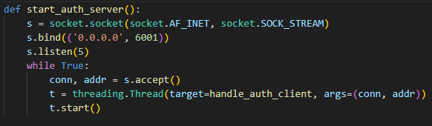
The auth_server creates a handle_auth_client thread that handle each connected client separately.

handle_auth_client()
This function work as the core authentication handler for the whole system. It run in the client-server model where this server act as the authority and every client must talk with it first before allowed to join anything else. Communication use IPv4 with TCP sockets so the data always come stable, not mixed, not out of order. The function read one full message from client, split it with ‘|’, and decide which operation to perform.

Commands that clients use to interact with server:
We introduced some commands so that the whole chat system can talk in one simple language between client and server. These commands are just small text words like SIGNUP, LOGIN, LOGOUT and GET_ONLINE, or a combination of these with ‘|’ sign, and they control the full logic of authentication. All commands travel through TCP over IPv4, so each message reach the server in correct order without mixing.
SIGNUP is used when a new user want to make account in the system. Client send username and password with this command, and server try to store them in the users database. If username already exist, signup break and server send back “0”. If everything is ok, server send “1” and also make entry in online status table.
LOGIN is used when already registered user want to enter the system. Client send username and password, server check inside database if password match exactly. If match is good, server mark that user online and send “1”. If something wrong, server just send “0”. This command also help server track user status so group chat know who is present.
LOGOUT is used when user is leaving the system. Client send username and server update that user as offline inside the online_status table. Time of logout is also saved so admin can see last active moment. Server reply “1” to confirm it receive the request.
GET_ONLINE is used when client want to know which users are currently online. Server search online_status table for all usernames where is_online = 1 and send them back in small text list. This make the chat feel like real system where you can see who is active.

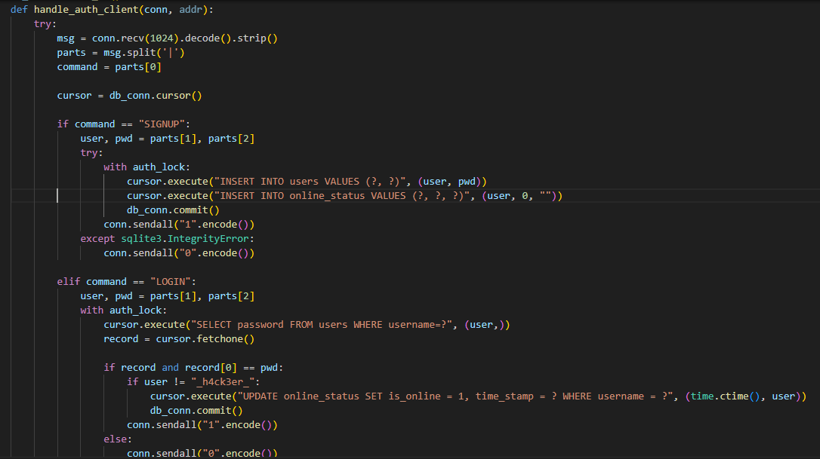

client_soc(client, i, m, stop_event)
This function handle one client inside the group chat. It receive the messages from that client through TCP, which make the whole communication more reliable and less messy. When the server get a message, it print it first and then send the same message to all the other connected sockets. This is like a small broadcast system where server act like a middle-man and share the message to everybody else. If the client send nothing, or send ';', or some error happen, the function just stop, remove that client from the list, and close the connection. This keep the chat from breaking even when someone leave suddenly or behave weird.

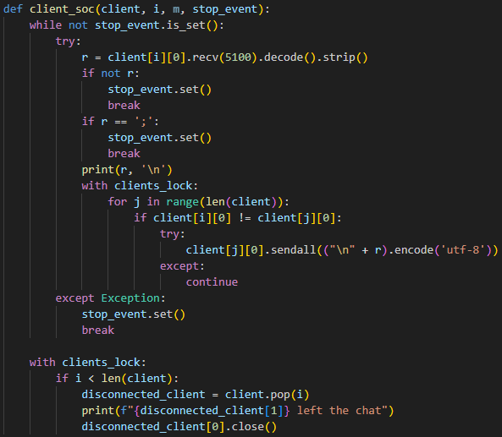

GroupChat()
This function is the main place where the full chat system start working. It launch the authentication server in background and then open the main chat server on port 5000 using IPv4 and TCP again. The whole design is plain client-server model: clients connect to the server, and the server pass messages around. The admin type their name and also decide how many clients can join. When a client arrive, the server accept the socket, read the client’s name and then send back the admin name. After all allowed clients join, the server create one thread per client so messages can move at same time without waiting. The group chat work by a simple cycle:
- client send text → server receive → server forward to other clients.
Everything go through the server like a central hub. This function make the chatting actually happen.

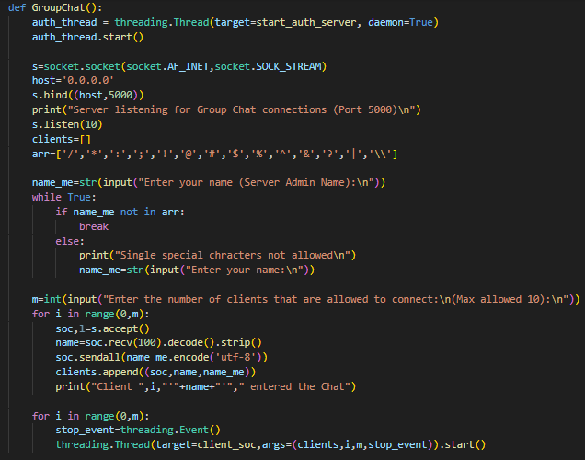
Working Mechanism of Client.py Backend:

We designed the client file to let users connect with server and other peers for chat. It work with TCP/IP (IPv4) and uses threading to let send and receive messages at same time. Client must connect server first for group chat, else it will not work.

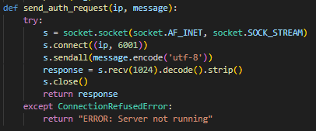

- This function send command message (like SIGNUP, LOGIN, LOGOUT, GET_ONLINE) to authentication server at port 6001.

- It connects to server using TCP socket.
- Sends the message and waits for response.
- Returns server response to caller.
- If server not running, returns error.

- The below function handles login and signup for client.

- Shows menu: Login, Signup, or Back to main menu.
- Login: asks username and password, send `LOGIN|username|password` to server. Server reply "1" if success, "0" if fail.
- Signup: asks new username and password, send `SIGNUP|username|password`. Server reply "1" if success, "0" if already exists.
- Back: return None to go main menu.
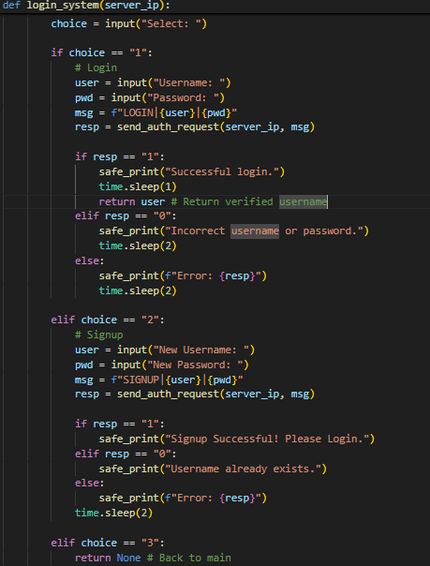

- The below function handles peer-to-peer direct chat.

- Client can choose to host chat or connect to peer.
- Hosting: bind to port 6000, wait for peer to connect.
- Connecting: ask peer IP, connect to port 6000.
- Send and receive messages simultaneously in loop using blocking recv/send.
- Chat ends when either send `;`.

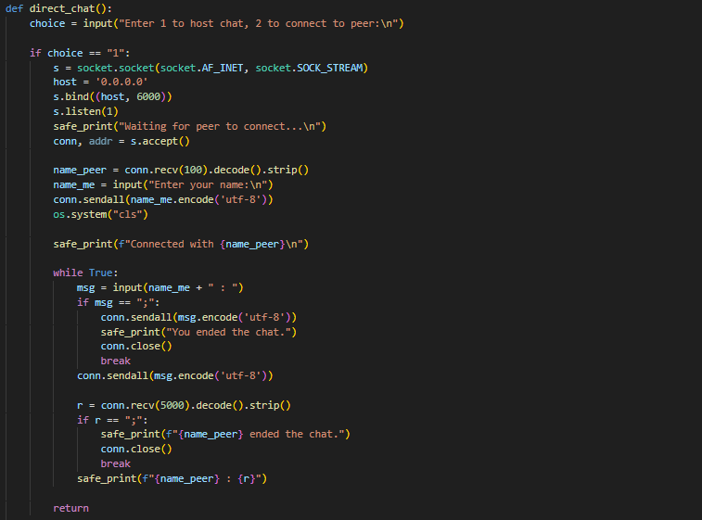

- This function handles group chat via server.

- Connects server at port 5000.
- Sends logged-in username to server.
- Receives admin name from server.
- Starts two threads: one for sending messages, one for receiving messages.
- Messages sent with format `username:message`.
- Chat ends when user sends `;` or server closes connection.

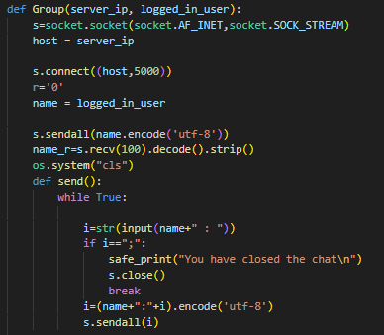

- The below function is the main controller for group chat mode.

- Ask server IP.
- First, calls `login_system()` to login or signup.
- After login, shows dashboard: Join Group Chat, Check Online Users, Logout.
- Join: call `Group()` to start group chat.
- Check Online: sends `GET_ONLINE` to server and prints online users.
- Logout: sends `LOGOUT|username` command to server.

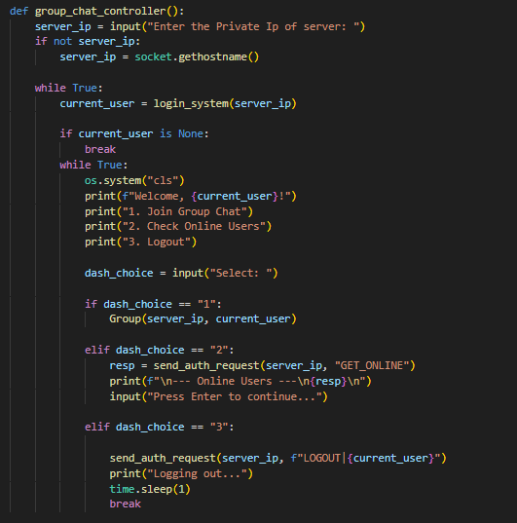

Main menu loop:
- Client can select mode: Direct Chat (peer-to-peer), Group Chat (server), or Exit.
- Direct chat calls `direct_chat()`.
- Group chat calls `group_chat_controller()`.

Features implemented in Client File
- Multi-threading for simultaneous send/receive
- TCP sockets using IPv4
- Peer-to-Peer Networking Model
- Group chat via server
- Signup, login, logout authentication
- Safe printing of messages in multithreaded environment
- Command-based protocol for server interaction (SIGNUP, LOGIN, LOGOUT, GET_ONLINE)
- Graceful chat termination (`;` to end chat)
- Online user checking
- Error handling if server not running

Working Mechanism of Database Backend

Purpose:
The purpose of implementing a database within the project was to keep track of all users, their passwords and online statuses, so that users could be authenticated via their passwords and unique usernames. The purpose of online status was to allow current online users of a particular session to identify other online users and possibly start a new chat room with them.

Implementation:
Below is the code used to create a database and within it, a table User_info()
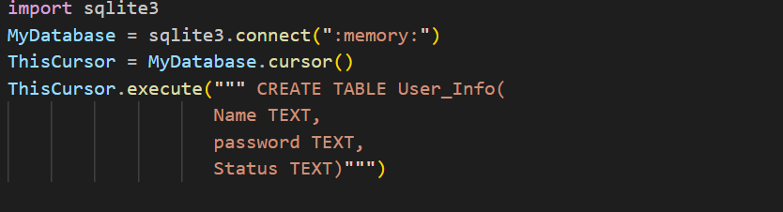

This creates a table with the columns name, password and status

Sign up/Login Function:

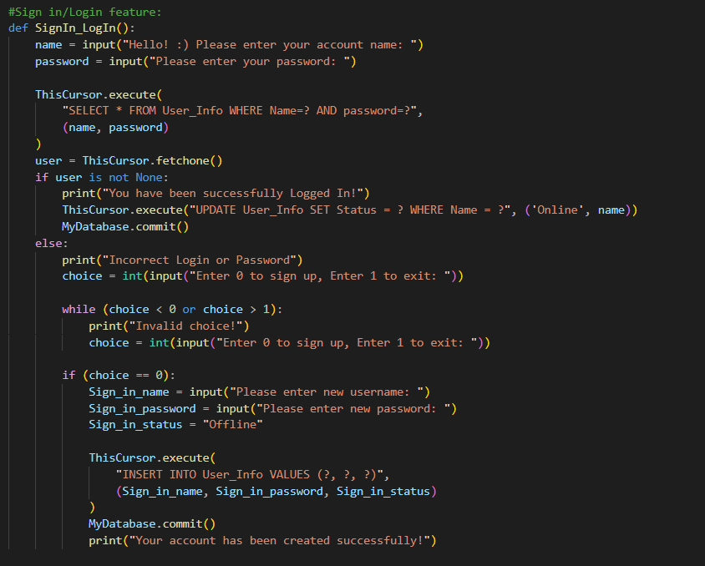

The above code is a function to Sign in and login, user is prompted to login, the input information is checked via .fetchone(). If the login exists, the user’s status is changed from offline to online, to allow other users to identify current user and changes are saved in the database using MyDatabase.commit(). if the login does not exist, the user is prompted to either sign up or exit.

Error Handling for Sign up/Login Function:
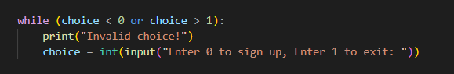
Appropriate error handling has been done to not allow user to enter any other option besides sign up or exit. If the user decides to sign up, name and password are taken as input, however status is automatically set to Offline.
The changes are then saved via Database.commit().

Current_Online() function:
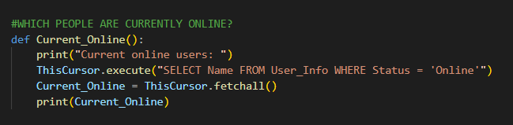
This function allows current user to view which other users are online during the current session

Working Mechanism of Client GUI Backend

This part of the report analyses the Graphical User Interface (GUI) of the “Chat Application”. The interface is built using Python`s standard GUI library Tkinter. The follow multiple windows approach, allowing the users to navigate between the main menu, peer to peer direct chat system, and server base group chat system using the distinct windows and dialogs.

Purpose:
The Graphical User Interface (GUI) bridges the gap between the developer’s vision and the user’s needs. Adding GUI helps developers see their application from a user’s point of view which guides the developers in making decisions regarding the scalability of their application.

TERMINOLOGIES AND LIBRARIES
The UI is constructed using Tkinter module and its submodules:
- Tk: the main root window
- Toplevel: Secondary independent windows (used for the chat rooms and dashboard)
- Frame: Canter to widgets to organize the layout.
- ScrolledText; a text widget with built-in scrollbar for the displaying the chat history.
- Simpledialog: Pop-up input boxes for capturing the IP addresses passwords.

Architecture and Navigation Flow
This application uses a hierarchical window structure. The application does not clutter a single window, instead, it open and closes window based on the user`s context.

Navigation flow:
- Root Window (Main Menu): The entry point.
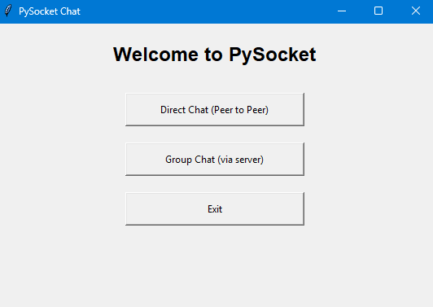

- Direct Chat: Opens a setup window --→ Transformation to the Chat interface.
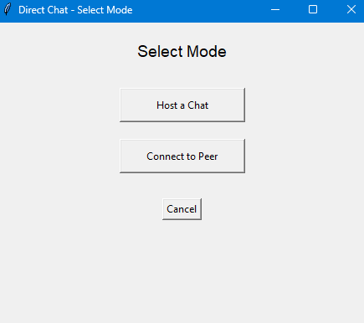 →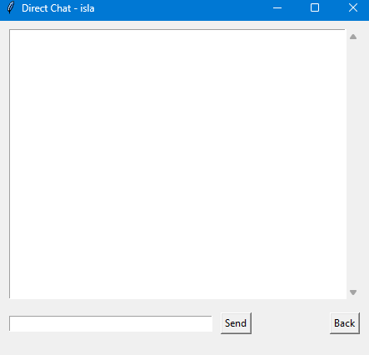→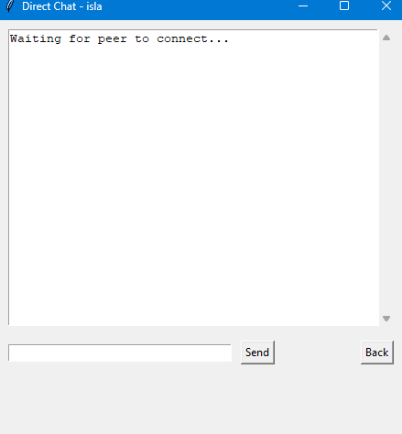
Direct Chat Window Peer windows Host windows

- Group Chat: Opens IP input →Authentication Window → User Dashboard → Chat Interface.

Dialogs and Alerts:
The application uses native OS dialogs to handle the user interaction cleanly:
- messagebox.showerror: Used when a connection fails or login credentials are wrong.
- messagebox.showinfo: Used to confirm successful signup or display the list of online users.
- simpledialog.askstring: Used to keep the main interface clean by offloading input tasks (like entering an IP address) to temporary pop-ups.

Working Mechanism of Server GUI Backend

- Flow and Architecture:
Unlike the client-side, the server-side system is based on the concept of utilizing a single window for its two main purposes:
- Group-Chat Administrator Login and Group-Chat initialization
- Viewing the Group-Chat and ending the server
Instead of utilizing a multi-window approach, the server-side has been set up to clear out the window after each phase of the application’s flow.
- Landing Page:
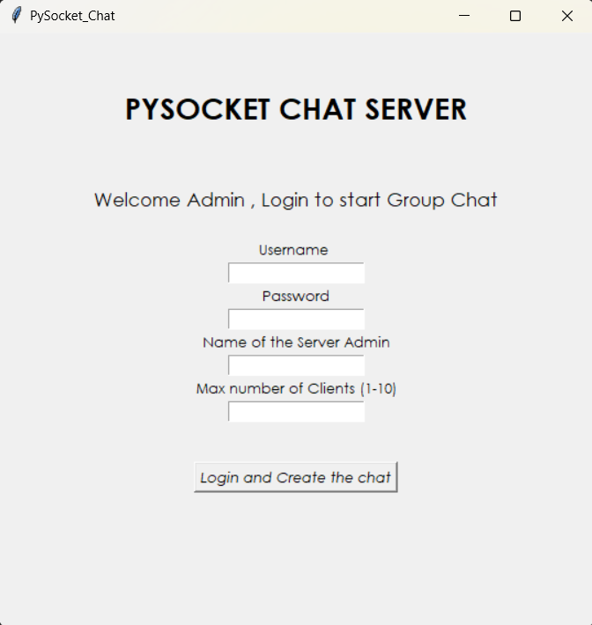

Figure 1

- Initialized Group-Chat:

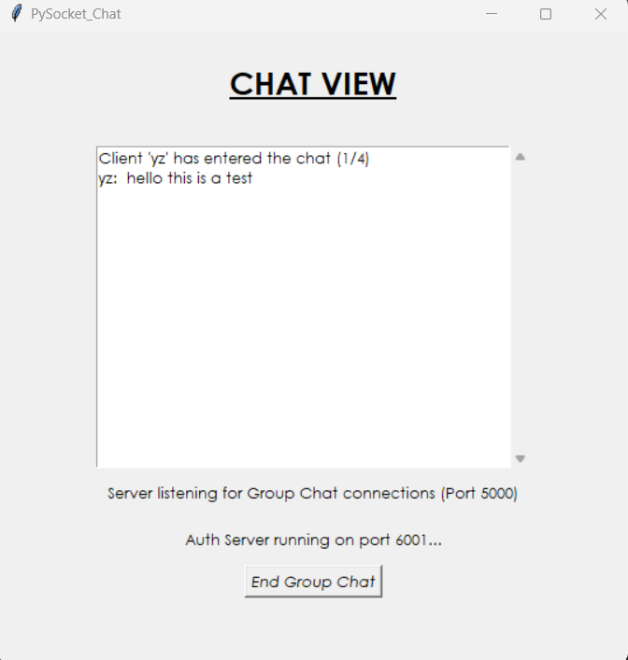

Figure 2

Library, Functions, and Definitions:
Like the client-side GUI implementation, the server-side also utilizes the standard Python GUI library Tkinter and its scrolledtext module, which has been imported to create the chat-box when viewing Group-Chat.

- Basic Landing Page Elements: The Label widget has been used to display the text on the sign-in page as well as taking in data from the user for verification and initialization of Group-Chat.
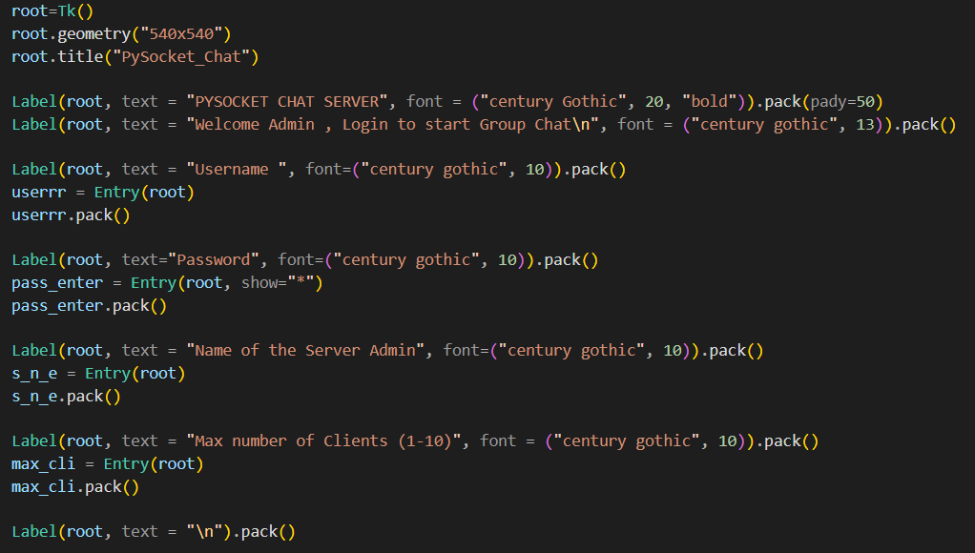

Figure 1

- Window Clearing: In order to not use multiple windows for the server-side, a function clear_window that deletes all the login page widgets from the window leaving behind a clear window.
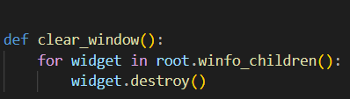

Figure 2

- ScrollBox Creation: Functions to simplify the Label creation and displaying process has been made. A scrolledtext variable has been declared which is used in the function to make the scrollbox and display the client messages by changing the attribute of the scrollbox from normal (when adding the messages) to disabled after the messages have been added.
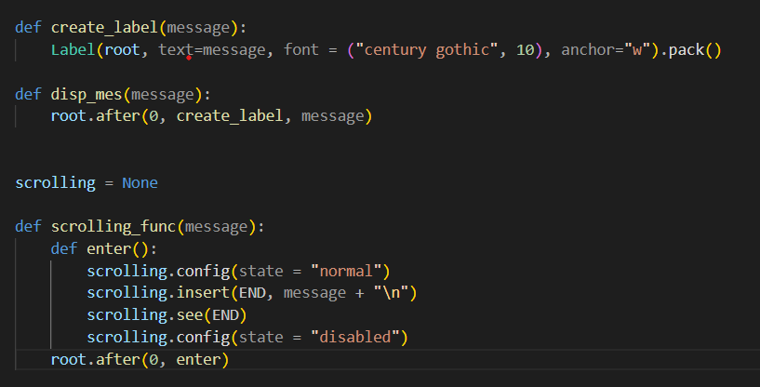

Figure 3

- The guiii() function: This function is called by the button on the login screen. Global variables for storing key information required after the login page (administrator name and number of clients allowed in chat) are declared because after the window gets cleared, the local variables and widgets get deleted. After a successful admin login, the window is cleared and the Groupchat() function is called.
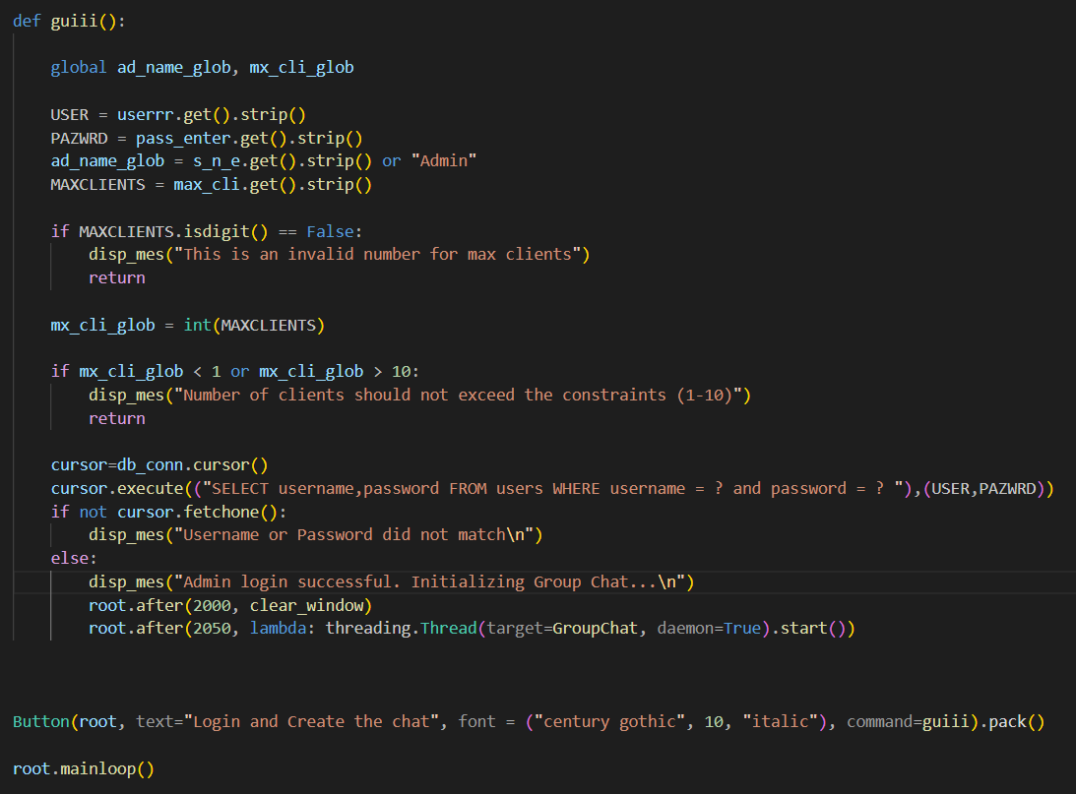

Figure 4

- The Groupchat() function: The key GUI involvement in this function is the creation and display of the scrollbox as well as the reassignment of the global admin name and max number of clients variables.

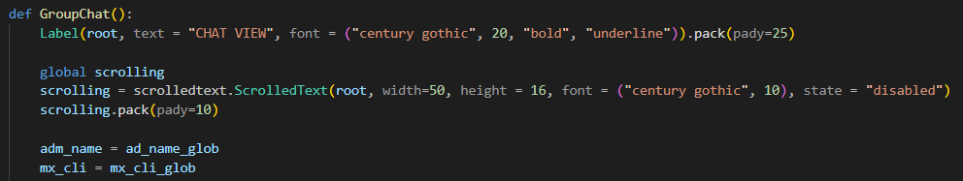
Figure 5

- Function calls for disp_mes() and scrolling_func(): According to how a message should be displayed (either normally or within the scrollbox) either of these two functions are called.
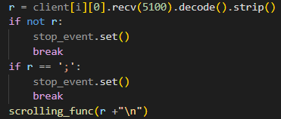

Figure 6

